**Project Design Phase-II**

**Smart Sorting : Transfer Learning For Identifying**

**Rotten Fruits and Vegetables**

**(Technology Stack (Architecture & Stack))**

|  |  |
| --- | --- |
| Date | 27 June 2025 |
| Team ID | LTVIP2025TMID59297 |
| Project Name | Smart sorting: transfer Learning For Identifying Rotten Fruits and Vegetables |
| Maximum Marks | 4 Marks |

**Technical Architecture:**

The Deliverable shall include the architectural diagram as below and the information as per the table1 & table 2

**Architecture Description:**  
A web-based intelligent classification system that allows users to upload images of fruits/vegetables, which are processed through a pretrained transfer learning model (e.g., MobileNet, VGG16) to classify them as **fresh** or **rotten**. Results are displayed via a UI, with admin controls for dataset management and retraining.

**Architecture Includes:**

* User interacts via web UI
* Frontend sends image to backend via Flask API
* Backend processes image using CNN transfer learning model
* Classification result is returned and displayed
* Admin manages datasets and retrains models
* All data (images, logs, feedback) is stored locally/cloud

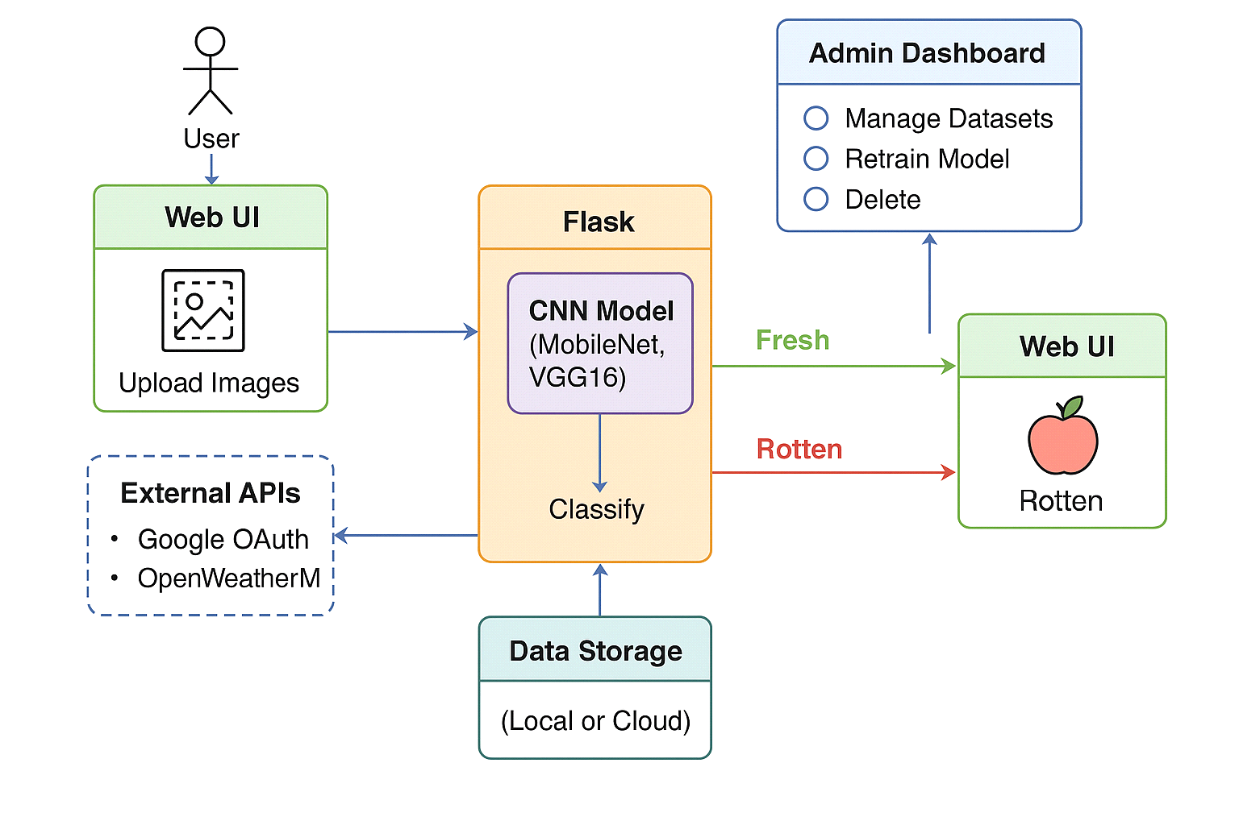

**Table-1 : Components & Technologies:**

|  |  |  |  |
| --- | --- | --- | --- |
| **S.No** | **Component** | **Description** | **Technology** |
|  | User Interface | Interface for image upload, result viewing, and admin panel | HTML, CSS, JavaScript, Bootstrap |
|  | Application Logic-1 | Image upload and preprocessing logic | Python + Flask |
|  | Application Logic-2 | Image classification using ML model | Transfer Learning (MobileNet / VGG16) |
|  | Application Logic-3 | Dataset feedback and retraining module | Python, TensorFlow / Keras |
|  | Database | Storage of prediction results and feedback | SQLite / MySQL |
|  | File Storage | Storage for image uploads and training data | Local Filesystem / AWS S3 |
|  | Machine Learning Model | Transfer learning for fruit/vegetable classification | CNN (MobileNet / ResNet / VGG16, etc.) |
|  | Infrastructure | Model runs on local server; scalable to cloud deployment | Localhost / Flask Server / Google Colab / AWS EC2. |

**Table-2: Application Characteristics:**

|  |  |  |  |
| --- | --- | --- | --- |
| **S.No** | **Characteristics** | **Description** | **Technology** |
|  | Open-Source Frameworks | Deep learning, backend, frontend frameworks | TensorFlow, Flask, Bootstrap, React (opt.) |
|  | Security Implementations | Authentication, data access control | OAuth 2.0, HTTPS, SHA-256 |
|  | Scalable Architecture | Can shift from single-tier to 3-tier or cloud-microservice-based system | Flask APIs, AWS EC2, Docker (optional) |
|  | Availability | Can host via cloud servers with failover | AWS / GCP / Heroku |
|  | Performance | Optimized image preprocessing, batching, and model caching | TensorFlow Lite (optional), Flask Caching |